**Infrastructur_as_code_with_Terraform:**

Why Terraform:  
There are great preexisting tools like Ansible, Chef, Puppet, Salt Stack. Terraform better than these tools.

Orchestration – Terraform is a server orchestration tool. All the above-mentioned tools are created for server configuration meaning that their primary goal is to install and manage s/w on the already existing server. Terraform concentrates more on server provisioning with s/w container deployment left to docker.

Immutable Infrastructure – With above-mentioned tools any s/w update will run in place, thus every server grows a unique record of updates throughout its life cycle. This can quite often lead to so called configuration drift, when the differences in these configurations lead to bugs. Terraform addressees the issue by utilizing an immutable infrastructure approach. Where every new update of any parameter creates a separate configurations snapshot. This way updating the development environment goes smoothly and its completely bug proof.

Declarative Code – While chef/Ansible forces you to write step by step procedural instructions for reaching the desired state, terraform preferred describing the desired each state of the system and the tool itself deals with reaching the goal state. But why is it better? With the procedural code you need to think of all the recent events and processes that took place in order to write clear instructions. But with terraform you simply order the tool to do something with the currently active state of the system. Therefore, the code base remains quite small and easily understandable.

Client-Only Architecture – Terraform leverages the cloud providers API for provisioning the infrastructure which removes the need of additional security checks, running a separate CM server and multiple s/w agents. Ansible does this by connecting through SSH yet the capabilities are quite limited.

What is Terraform?

Terraform is an open source IaC tool developed by Hashicorp. It is used to define and provision a complete infrastructure using an easy to learn declarative language called HCL (Hasicorp configuration language). Terraform supports multiple providers such as AWS, AZURE, Kubernetes, Google cloud and many more.

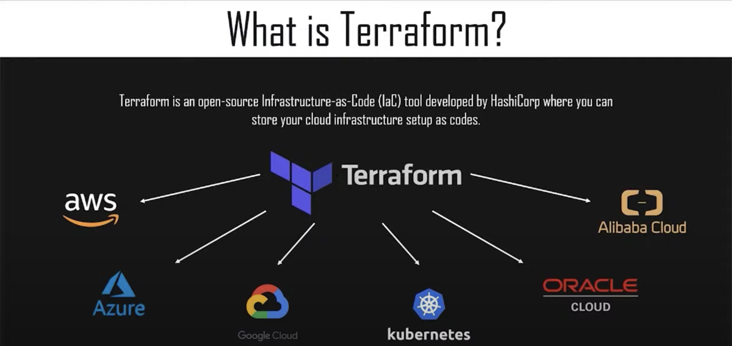

Terraform use case:

Rapyder is a Agile innovative company. They are providers of strategic cloud consulting, Cloud migration, Devops automation, Manage services and Security consulting. Once their client was looking for a cloud agonistic tool to orchestrate the infrastructure on to multiple public clouds. They wanted the infrastructure to be up in a matter of few minutes. The client has different environments like production, staging and QA to test. DB backups were also included as a part of infrastructure setup.

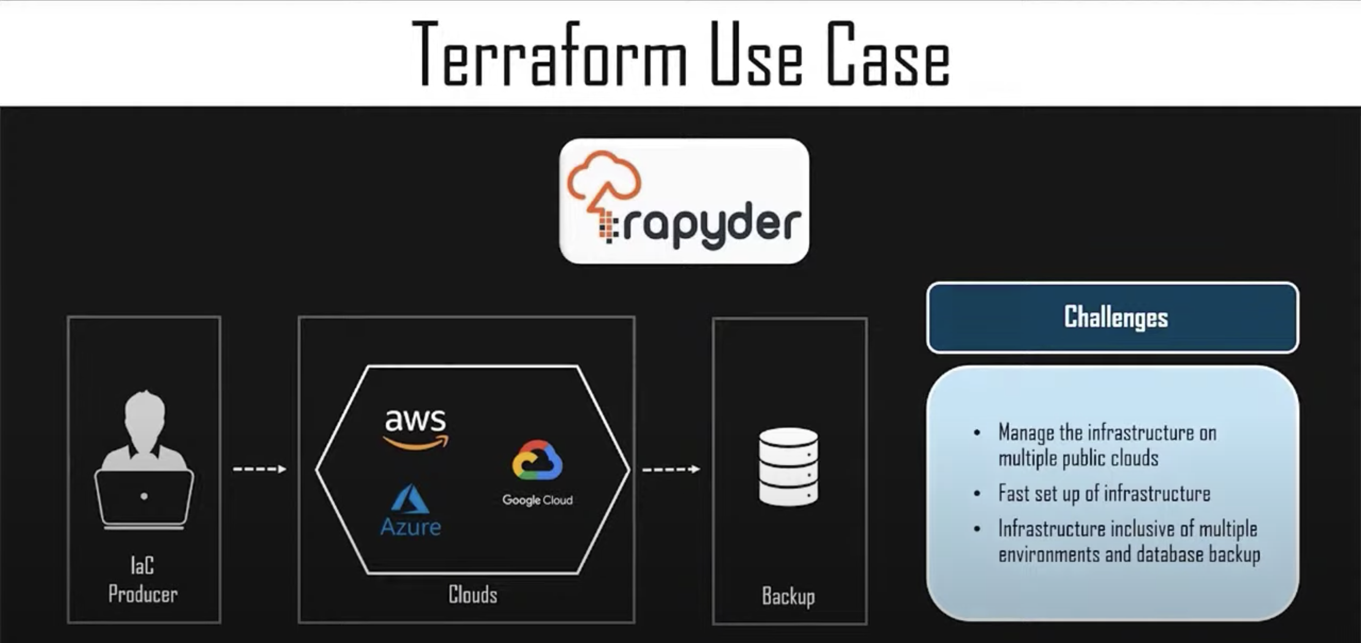

Devops engineers at Rapyder reviewed and analyzed the client’s requirement and came up with a solution of using terraform. To codify the provisioning of infrastructure on to public cloud. Not only infrastructure they also automated the application deployment process by integrating Gitlab to improve the s/w development and accelerate the s/w delivery. The solution provided by Rapider also took care of DB backup, for a situation where the infrastructure is destroyed. Using this solution, the client can test their application and deploy it on production environment without downtime.

Overall benefits that a client could experience is :

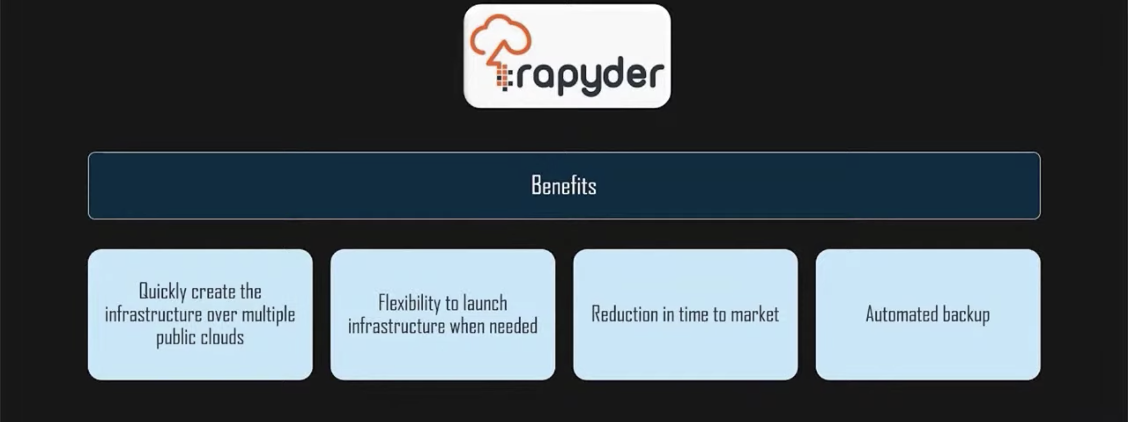

Terraform Lifecycle:

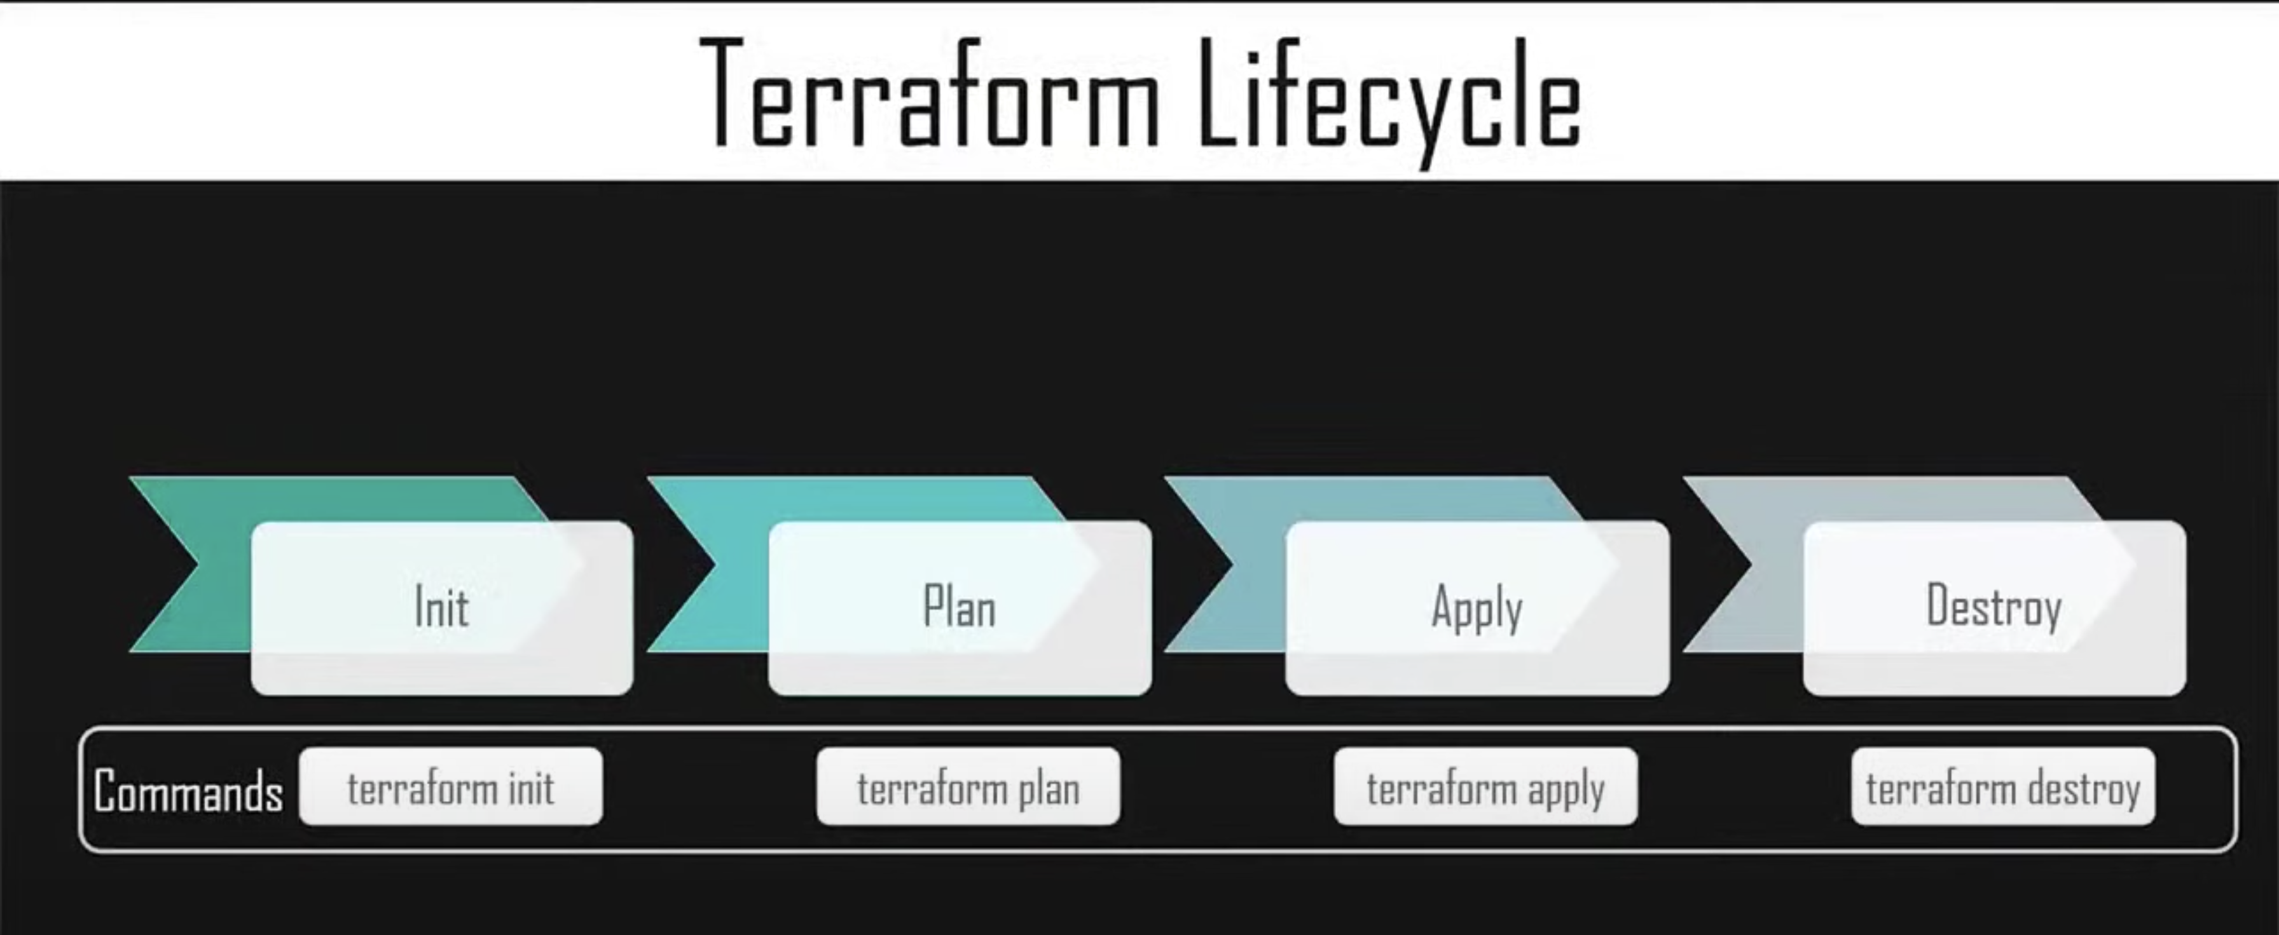

Terraform init: it initializes the working directory which consists of all the configuration files.

Terraform validate: If any syntactical errors exist, the output lists the errors.

Terraform plan: It is used to create the execution plan to reach a desired state of the infrastructure.

Terraform apply: It will then make the changes in the infrastructure as they find in the plan and the infrastructure comes to the desired state.

Terraform destroy: It is used to delete all the old infrastructure resources which are marked tainted after the apply phase.

How does Terraform works?

Terraform core used two input sources to do its job. The first input source is a terraform configuration file that you as a user configures. Here you define what needs to be created or provisioned. The second input source is a state where terraform keeps the up-to-date state of how current setup of infrastructure looks like. So, what terraform code does is, it takes the input, and it figures out the plan of what needs to be done. It compares the state and checks what is the current state and what is the configuration that you desire in the result. It figures out what needs to be done to get the desired state in the configuration file.

The second component of architecture is providers for specific technologies. This could providers like AWS, AZURE or other infrastructure as a service platform. It gives you the possibility to create infrastructure on different levels. Terraform has 100’s of providers for different technologies and each provider then gives terraform user access to its resources.

For example, AWS provider gives you access to 100’s of AWS resources like EC2 instances, AWS users etc. With Kubernetes provider you can access commodities resources like services and deployments and namespace etc.

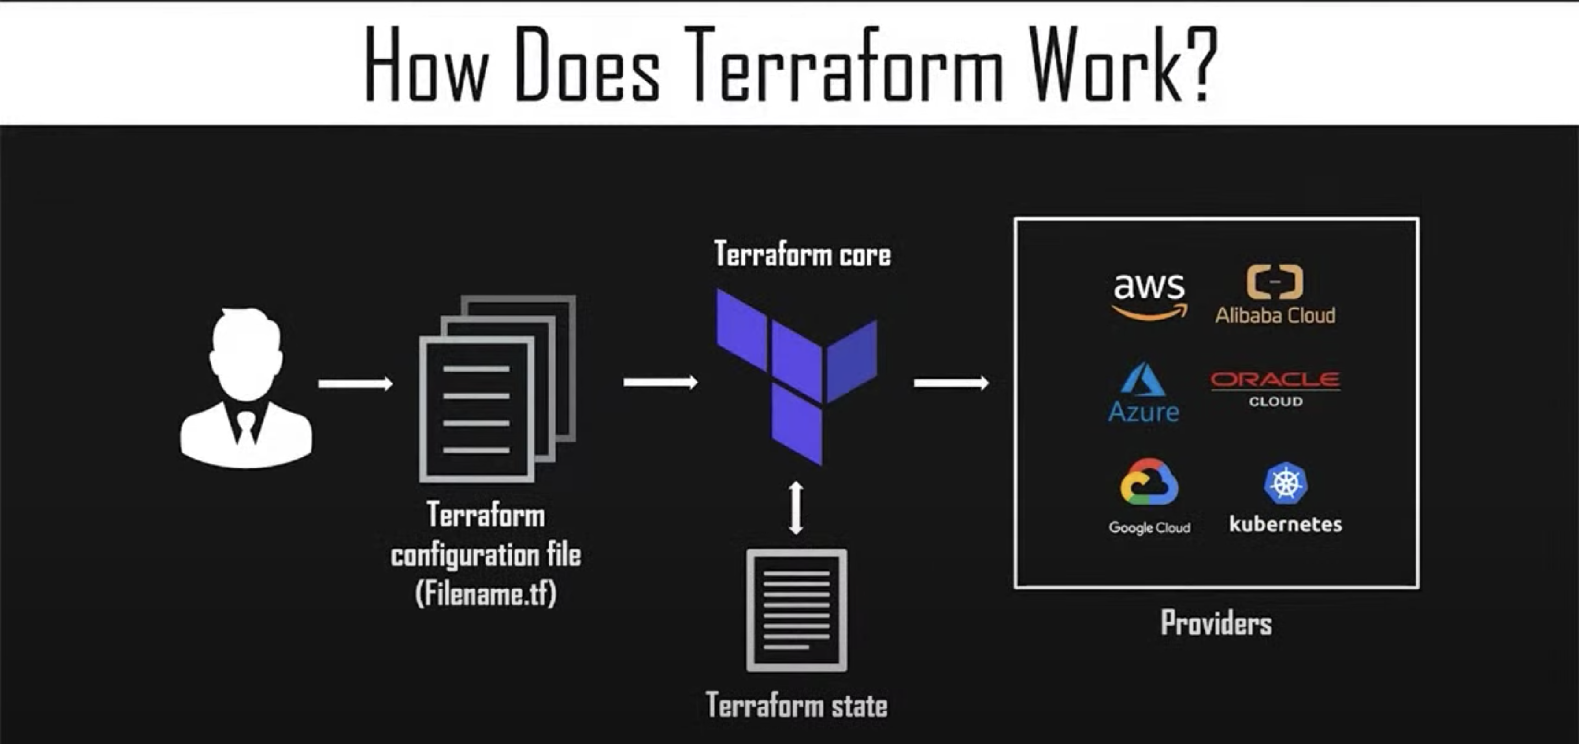

This is how terraform works. This way it tries to help you provision and cover the complete application setup from infrastructure all the way to the application.

Terraform Installation:

<https://www.terraform.io/downloads.html>

from linux:

wget <https://releases.hashicorp>.com/terraform/0.14.5/terraform_0.14.5_linux_amd64.zip

unzip terraform_0.14.5_linux_amd64.zip

sudo mv terraform /usr/local/bin/

terraform -v

terraform (to see list of terraform commands)

DEMO:

Lets create a directory and name it as terraform_demo

mkdir terraform_demo

cd terraform_demo

Now we are going to create a terraform configuration file over here

gedit demo1.tf (.tf is the extension for any terraform configuration file)

Here in the demo1.tf config file we are going to put all the configuration we need. Initially let’s try to create an EC2 instance in AWS and then destroy that EC2 instance.

Terraform provides you with everything and support that is there for your code online.

Search AWS provider terraform – search in google

<https://registry.terraform.io/providers/hashicorp/aws/latest/docs>

create a IAM user in AWS and give him programmatic and admin access and create access/secret keys.

Ec2 instance terraform – google search

<https://registry.terraform.io/providers/hashicorp/aws/latest/docs/resources/instance>

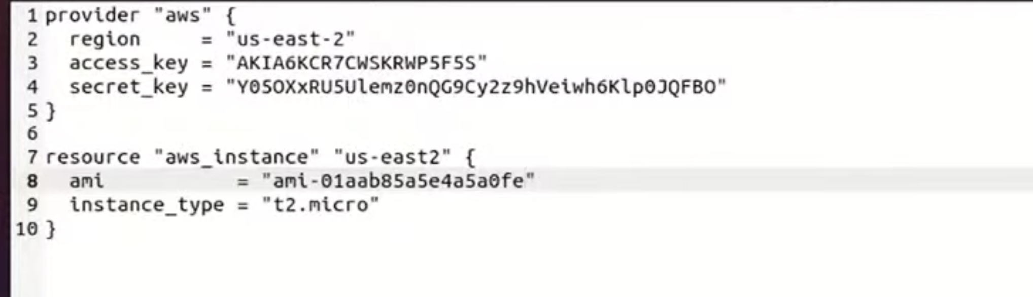

Save file.

Now we are going to initialize it –

terraform init

then apply terraform plan

terraform plan

you can see paln: 1 to add in the o/p. then we can use

terraform apply

this will create a instance in speacified DC. Go to aws and console and check.

After validating let destroy the created instance.

terraform destroy

this is a simple and easy example. Let’s create a more complicated one. Let’s try to add some more services that AWS provides you.

Let’s use the same demo1.tf file and edit it to create one more instance in another region along with same ec2 we have created earlier. And the AMI changes for every other DC. So you should go and pick AMI from the DC you want to create EC2 instance. So AMI differs from region to region.

So how will this resource will understand that it wants to create an EC2 instance in “us-east1” . So for that what we are going to do is, we are going to create an **alias**.

In the provider section

alias=”useast1” (you can give any name)

in resource section

provider=aws.<alias>

provider=aws.useast1

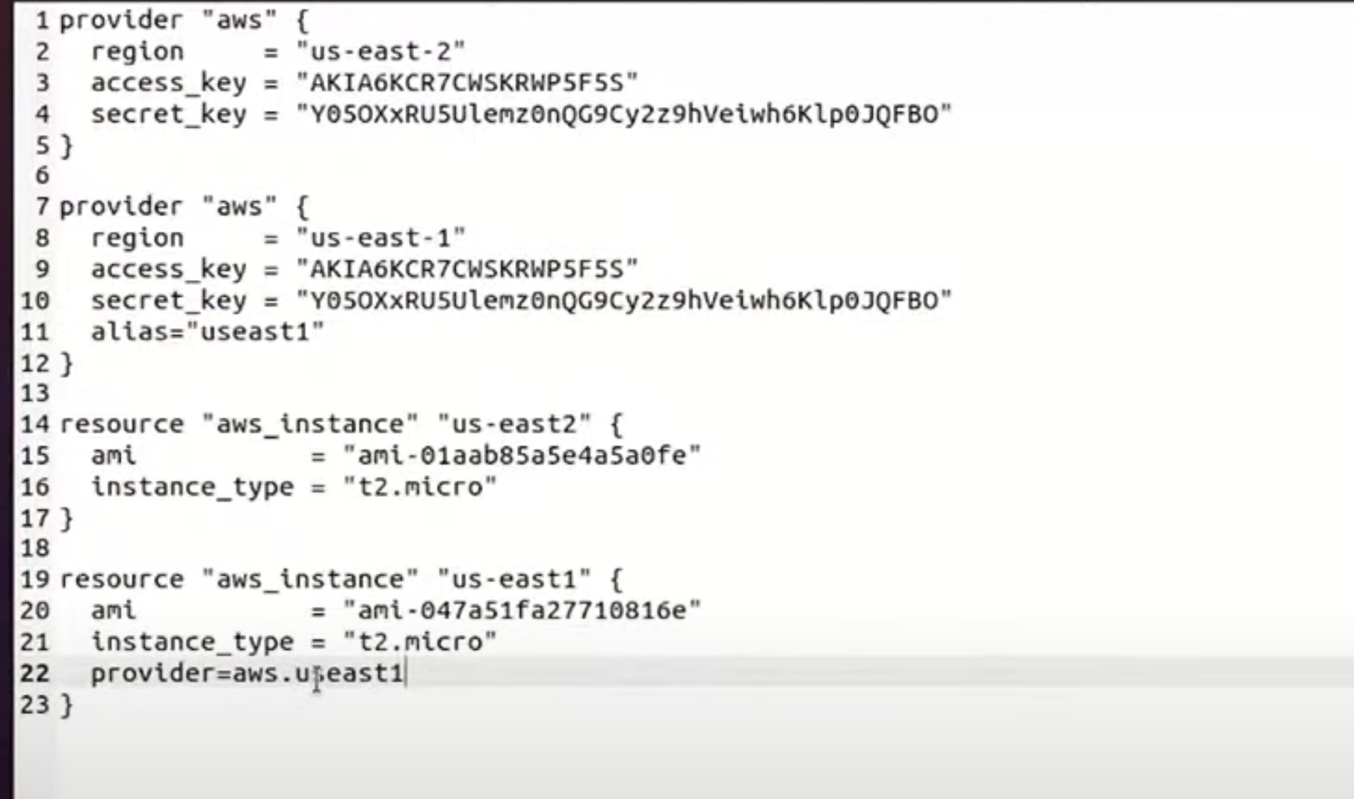

Apart from this let create an S3:

And remember bucket name has to be unique while creating s3 bucket.

Apart from S3 we gonna add versioning over. And why we are adding versioning here is because we want to preserve, retrieve and restore every version of every object stored in our amazon s3 bucket so that’s the reason we have added the versioning black in the file.

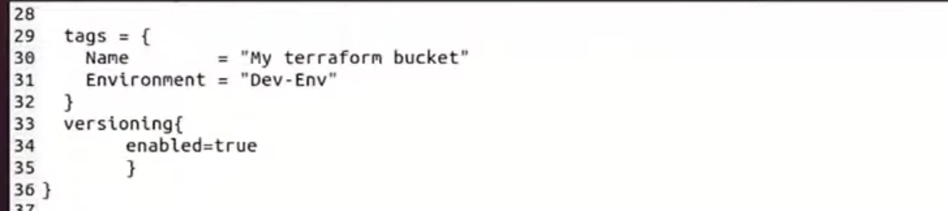

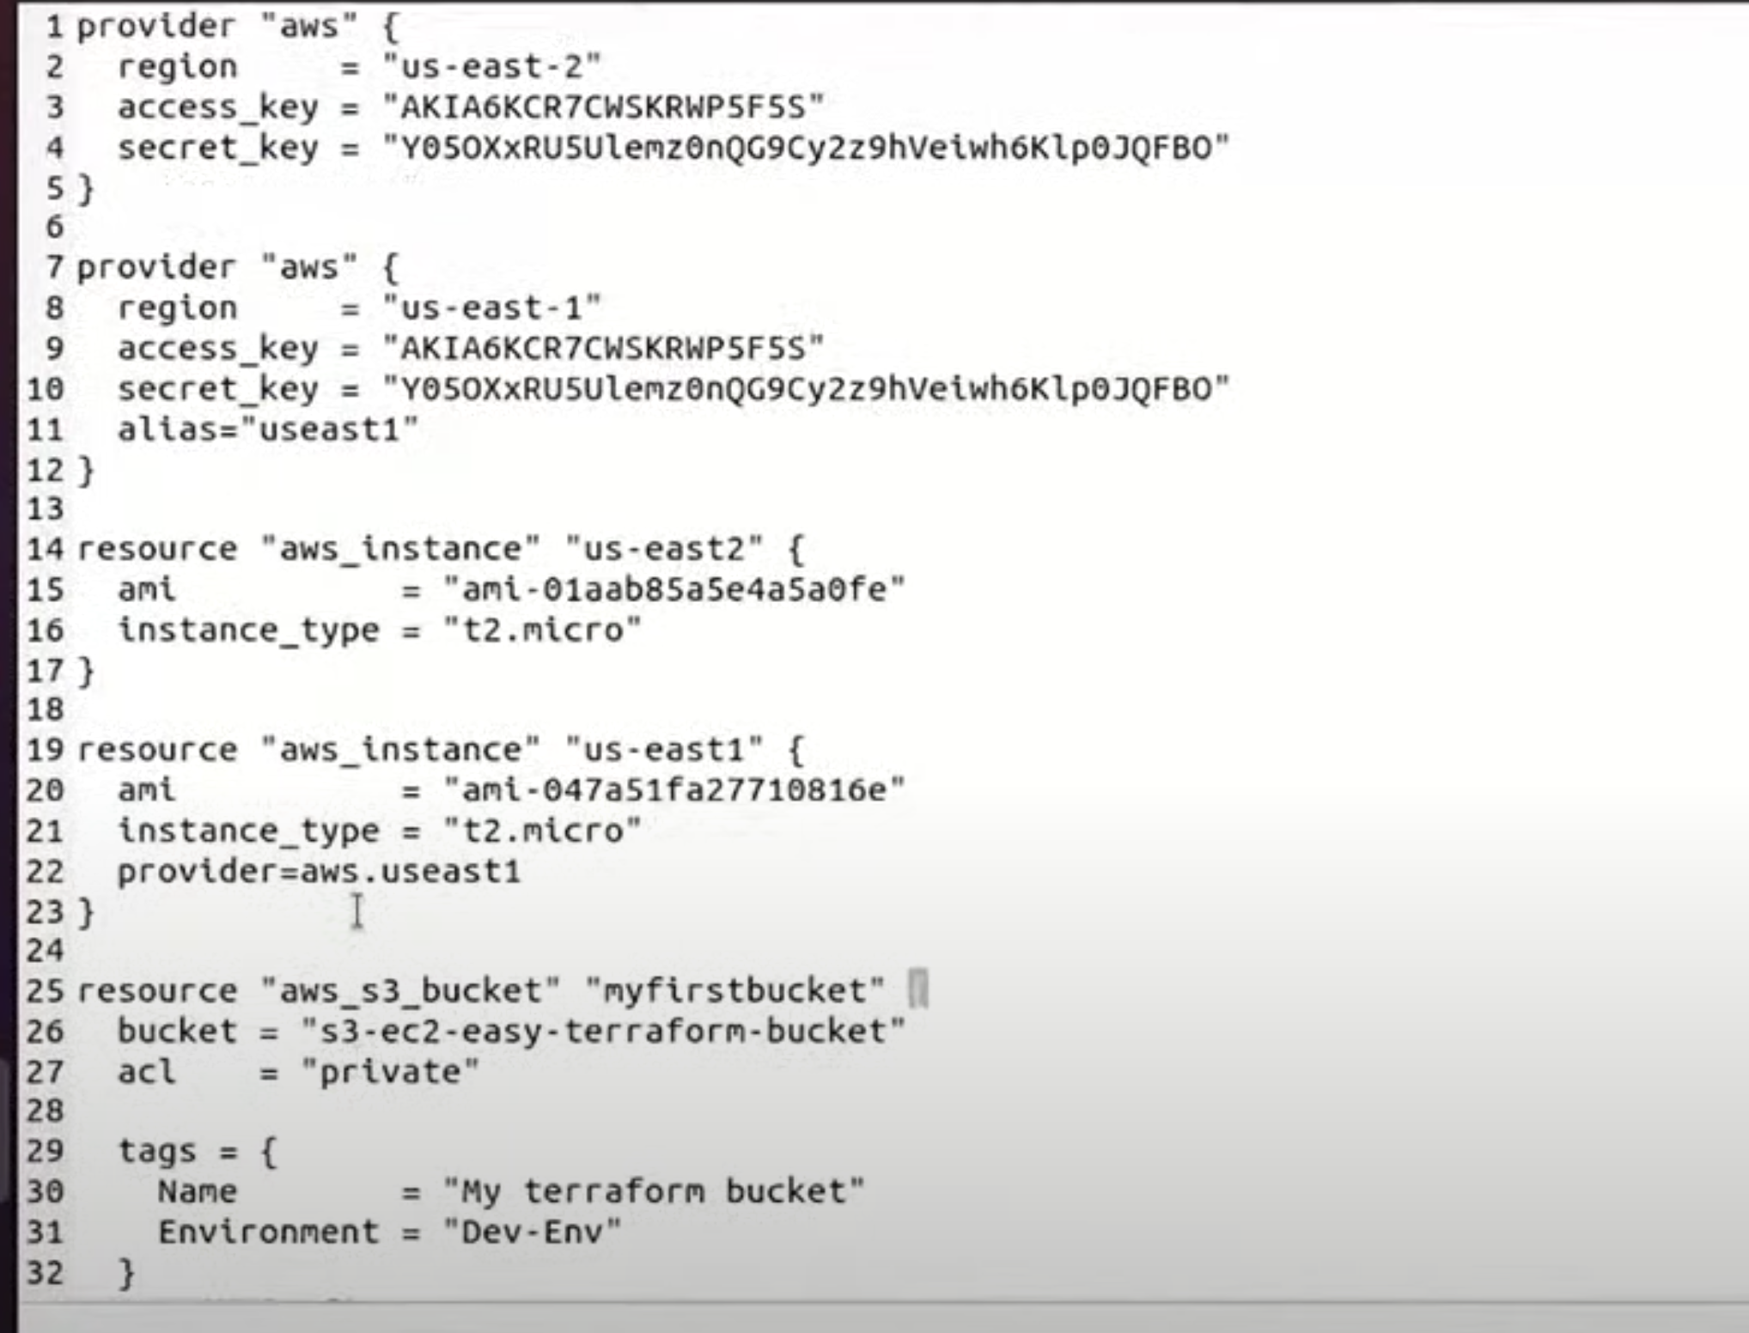

In case of us-east2 we haven’t used any alias, so what it is going to do is, it is going to refer to the default one where there is no alias and nothing provided for it. So its going to refer the defaulters.

Run terraform commands (init, plan, apply) and validate by going to console.

Now let’s say, we want to add a vpc, subnet, and also want to create relational database system(RDS).

So, 3 more things:

Vpc, subnet and RDS.

So, what we can do Is, we can add these to same conf file rather than creating another file. But 1 thing to remember, we have not destroyed any of the resources which we created above.

Let’s start adding code for vpc first,

Give its name as dev

Cidr block let’s keep it to default,

Change tags name to “dev-vpc”

Add subnet:

Name : sub

Cidr block default

Tags name: dev-subnet

And we also need to provide vpc_id here but we haven’t created any vpc Id yet. So we can copy vpc resource name and copy it to subnet resource.

Vpc_id = Aws_vpc.dev.id

For RDS,

Change-

Resource name to “projectdb”

Engine_version = 8.0.19

Name = “myterraformdb”

Parameter_group_name = “default.mysql8.0”

And we will add one additional line as we don’t we to create a snapshot of this RDS that we are creating. Suppose this is a dummy rds we have a created for testing and we don’t want any backup for this.so we are going to provide that we don’t want the snapshot.

Skip_final_snapshot = true





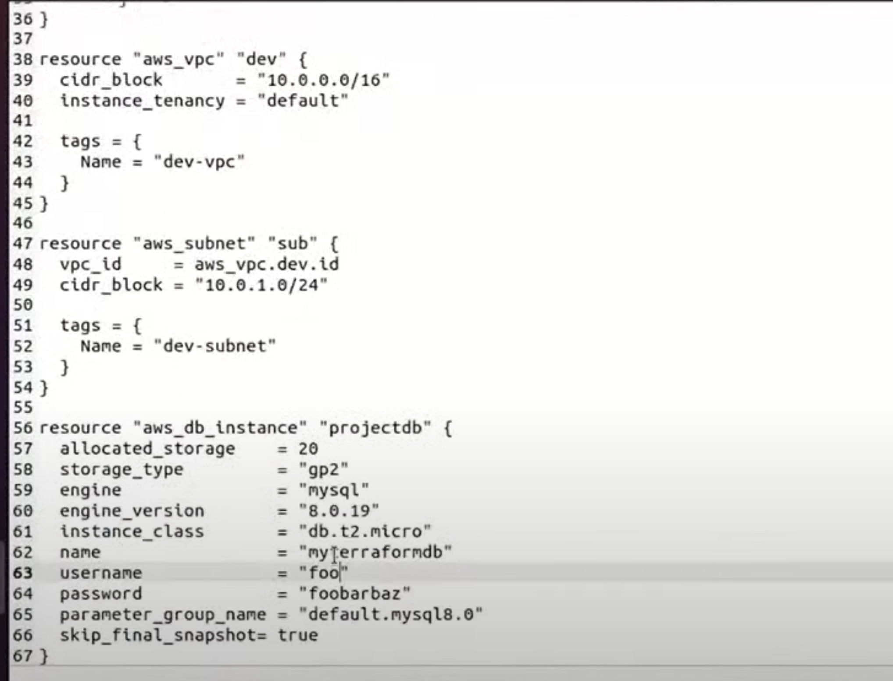

Let’s save this file and run terraform commands.

And go to console and validate the newly created 3 resources. The previously created resources are already available and hence terraform hasn’t created duplicates for them.

And then we can destroy all the 6 resources now.

Terraform destroy

To delete a specific resource, run the following command:

terraform destroy -target=resource_type.resource_name

terraform destroy -target=aws_vpc.dev (to delete vpc from above)